Extract from Report
KWAZULU-NATAL TOURISM

INTRODUCTION
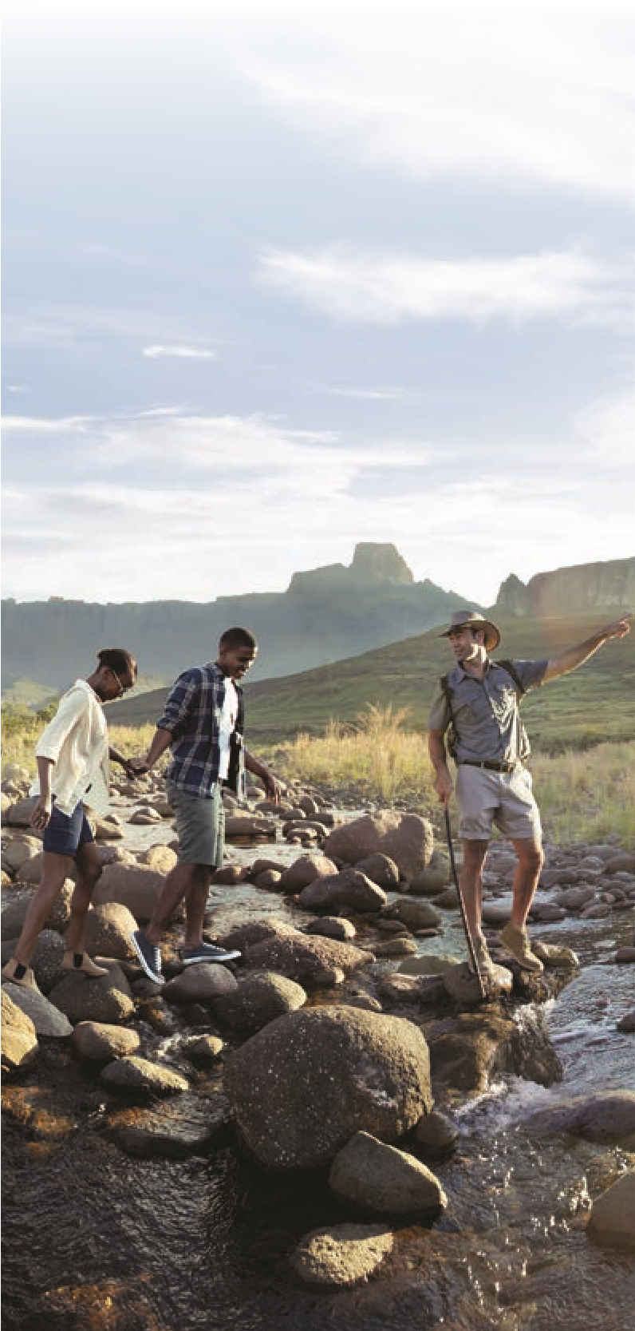
The year 2019/2020 was one of our best performing years, where we saw millions of local and foreign visitors flock to our shores to explore the diverse range of activities and landscapes – like the sea, mountains and bush – which the province has to offer.
Figure 1: Drakensberg
In the last two decades tourism has become an important economic sector for most African countries. In KwaZulu-Natal, there has been an increase in investments in product development and destination marketing, coupled with appropriate business-friendly socio-political reforms. Tourism's contribution to the economy of the province cannot be underestimated.
The exponential increase in domestic trips (Department of Statistics South Africa) to KwaZulu-Natal is testament to the hard work which has gone into promoting the province. In 2019, KwaZulu-Natal experienced a 112 percent increase compared to 2018 in domestic tourist trips which saw 6.2 million trips undertaken into and within the province. This places KwaZulu-Natal in one of the top two provinces for domestic tourism in the country. This is the most significant growth that KwaZulu-Natal has seen in the domestic front in the past seven years.
Strategically it means that tourism is able to fulfil its role as a catalyst for socio-economic change by employing more people, while the spin-offs have positive impacts on other industries such as the food and transport industry.
One of the major highlights ahead of the December holiday season in 2019 was the opening of Africa's longest promenade on the Durban beachfront. The addition to the existing promenade which stretches further south from uShaka Beach to the harbour entrance, makes it easier to navigate the beachfront for walkers and those who want to exercise. It also makes Durban CBD living more attractive for those who want to invest in residential property around the waterfront.
Another major event on the tourism calendar was the commencement of the building of a dedicated world-class passenger cruise terminal in Durban. The highly publicised sod-turning ceremony for the terminal marked the beginning of the R200-million green energy efficient terminal development, which will house several features, including a retail component and multi-purpose training, conferencing and event facilities. The terminal is due for completion in 2022.
This is a significant development for the tourism sector as the cruise industry is a major money spinner and thousands of tourists from around the country, and beyond, head for the Port of Durban every season to embark on their cruise holidays. Many of them boost the local tourism economy even further by staying in local hotels and going on tours either before or after their cruises. KwaZulu-Natal continues to work towards the implementation of the province's Tourism Master Plan, ensuring that tourism activities are not limited to big towns and cities but that they are expanded into lesser known geographical areas to boost those economies.
Question/Vraag 1.5
The vision is that, by 2030, KwaZulu-Natal will become globally renowned as Africa's top beach destination with a unique blend of wildlife, scenic and heritage experiences for all visitors. This plan is not just a government plan but is private sector driven and community-based.
There is already a strong private sector buy-in, good inter-governmental co-ordination and clearly defined roles for each stakeholder for the vision of the Tourism Master Plan to be fully realised.
Tourism KwaZulu-Natal continues to gain insight into traveller needs and as a means of researching the market to make the province more destination-friendly and, where needed, bring about improvements as quickly as possible.
In the year under review, the research shows that business events contributed an estimated R6 billion in the economy of the province and further created and sustained over 13 000 jobs for the people of KwaZulu-Natal. KwaZulu-Natal has catapulted to being one of the top business events destinations in the world. This was confirmed by the hosting of the World Football Summit which took place in Africa for the first time in history.
KwaZulu-Natal is a resilient province and will overcome adversity. The vision remains that of building a strong and sustainable tourism sector that improves the lives of all the province's people.
The tourism sector and all the people of KwaZulu-Natal are being prepared to welcome our tourists. As I indicated in my department’s Budget Speech delivered in June 2020, the reality of the matter is that the world’s top destinations are empty and we all have to start from scratch.
KwaZulu-Natal is working with industry stakeholders to improve the infrastructure at various tourism draw cards throughout the province, to ensure that health and safety measures are in place. A crisis like this also provides an opportunity to promote domestic and intra-African tourism and travel. This will serve as a catalyst for triggering recovery and stimulating growth in the industry.
Herein lies the purchasing power and potential contributions of the growing African middle-higher income classes to the industry.
KwaZulu-Natal are confident that they will emerge stronger from this situation, more innovative and show even greater tourism income than before.
This is a tribute to the board, Acting CEO, executive management and all categories of staff.

PUBLIC RELATIONS AND COMMUNICATIONS

Media Liaison and Press Statements
Throughout the 2019/2020 review period, KwaZulu-Natal worked closely with the media to ensure that journalists and commentators were informed about events and key initiatives.
During the period under review, 20 press statements were released dealing with a range of issues including Africa's Tourism Indaba, the Vodacom Durban July, festive season activations and the Lilizela Awards.

Hosting
During the period under review, KwaZulu-Natal collaborated with a number of social media influencers, celebrities and tourism writers to promote tourist experiences in the province. A highlight for the period includes the hosting of well-known entertainment celebrities and social media influencers who shared their experiences with their combined social media audience of more than 1 million followers.
During the same period KwaZulu-Natal hosted members of the media in several parts of the province to showcase a variety of offerings. The media were also taken on familiarisation trips to the Elephant Coast, Drakensberg, South Coast, Jozini Tiger Lodge, Pongola Country Lodge and a new hotel in Hluhluwe, etc.
Familiarisation also included key events hosted in the province, such as the Sardine Festival and the Umthayi Festival.

Media Monitoring
KwaZulu-Natal's smart advertising and marketing strategies paid off handsomely as destination KwaZulu-Natal amassed R113 312 719 in media coverage.
They also participated more aggressively on social media platforms, which proved to be a worthy investment as more and more tourism consumers use social media as a communications tool of choice. The publicity was widespread and included platforms such as Facebook, Twitter and YouTube.
However, it is worth noting that the destination also received a degree of negative publicity during the review period, attributable to the number of xenophobic attacks, perceived political instability and the outbreak of COVID-19. This gravely impacted on the overall image of the destination.

Public Relations
A series of events were held to attract tourists and simultaneously market the province as a key leisure and tourist destination and to enhance stakeholder relations with KwaZulu-Natal trade. From special gatherings of motorbike enthusiasts to air shows and the Vodacom Durban July, KwaZulu-Natal was determined to prove that the Kingdom had something for everyone.
The Africa's Travel Indaba breakfast drew international and national media and also many from across the African continent. An annual event hosted by KwaZulu-Natal, the breakfast is essential for positioning the province as a global player with national and international trade representatives with regard to marketing and tourism development activities in the province.
A flagship event on the national calendar, the Vodacom Durban July is one of the premier social and sporting events each year.
KwaZulu-Natal collaborated with the Department of Economic Development, Tourism and Environmental Affairs to utilise this platform as a networking opportunity to engage strategic stakeholders who play a role in helping to achieve the vision of making the province a leading tourist destination.
KwaZulu-Natal hosted the seventh provincial Lilizela
The Tourism Awards event was held on 30 October 2019 at the Fairmont Zimbali Resort. Winners went on to compete at the national event and for the second consecutive year, the province also scooped the award for Emerging Tourism Entrepreneur of the Year. Durban Tourism, the Department of Economic Development, Tourism and Environmental Affairs and Tourism KwaZulu-Natal hosted World Tourism Day at the Mandela Capture Site in the Midlands. uShaka Marine World, KwaZulu-Natal Wildlife and the KwaZulu-Natal Sharks Board also participated in an exhibition held there and interacted with the community of uMgungundlovu.

Pandemic
In the year under review the global pandemic made its presence felt.
The MEC for the Department of Economic Development, Tourism and Environmental Affairs, tasked the province with establishing a Tourism Recovery Task Team consisting of public and private sector representatives. The task team was responsible for formulating a provincial tourism recovery plan to mitigate the effects of the pandemic.
Question/Vraag 1.9

Question/Vraag 1.10

Question/Vraag 1.11

